**Summary:**

###### **Sales team :** Members of the sales team have direct interactions with customers and are highly attuned to how the company performed over the past year. They can provide detailed information on the types of data that will matter most to the company’s customers.

###### **Vice president of sales :** The VP of sales provides strategic and operational direction but is less interested in specific details. Ning prepares questions ahead of time to focus on the key findings that the company expects from an annual sales report.

###### **Data analytics team :** The data analysts on Ning’s team each have a dataset that they focus on and can help pull the various types of data that Ning needs to satisfy the other stakeholders. Ning collaborates with them to complete the report.

###### **Data science managers :** The data science managers oversee all of the company’s datasets and can help Ning prioritize the types of data and analyses required for the annual report. They can also advise on making an effective presentation.

As a data analyst, it’s important to communicate often. Sharing detailed notes and creating reports are ways to communicate with the people who have invested time and resources in a project. Who are these people : *Stakeholders*

The customer-facing team does which of the following activities? Select all that apply : *>Compile information about customer expectations || >Share customer feedback*

The human resources director approaches a data analyst to propose a new data analysis project. The analyst has a lot of experience in human resources and believes the director is taking the wrong approach, and it will lead to some problems. Select the data analyst’s best course of action : *Respectfully explain their viewpoints and offer the director some additional information to help improve the project.*

## 

## **Clear Communication:->**

As a data analyst, you'll get plenty of requests and questions through email. Let’s walk through an example of how you might approach answering one of these emails. Assume you're a data analyst working at a company that develops mobile apps. Let's start by reviewing answers to the four audience questions we just covered:



Kiri, Product Development Project Manager



Kiri received updates about our project from its planning stages, including the most recent project report, sent two weeks ago.



Kiri needs an update on the analysis project’s progress and needs to know that the executive team approved changes to the data and timeline. You know that adding a new variable to the analysis will impact the current project timeline. Kiri will need to change the project’s milestones and completion date.



You can start by sending an email update to Kiri with the latest timeline for the project, but a meeting might be necessary if she wants to talk through her concerns about missing a deadline.

## **Email Etiquette:Updated timeline email sample**

After answering the audience questions, you have the key building blocks you need to write an email to Kiri. Here's an example of how these questions can help organize the flow of the email message:

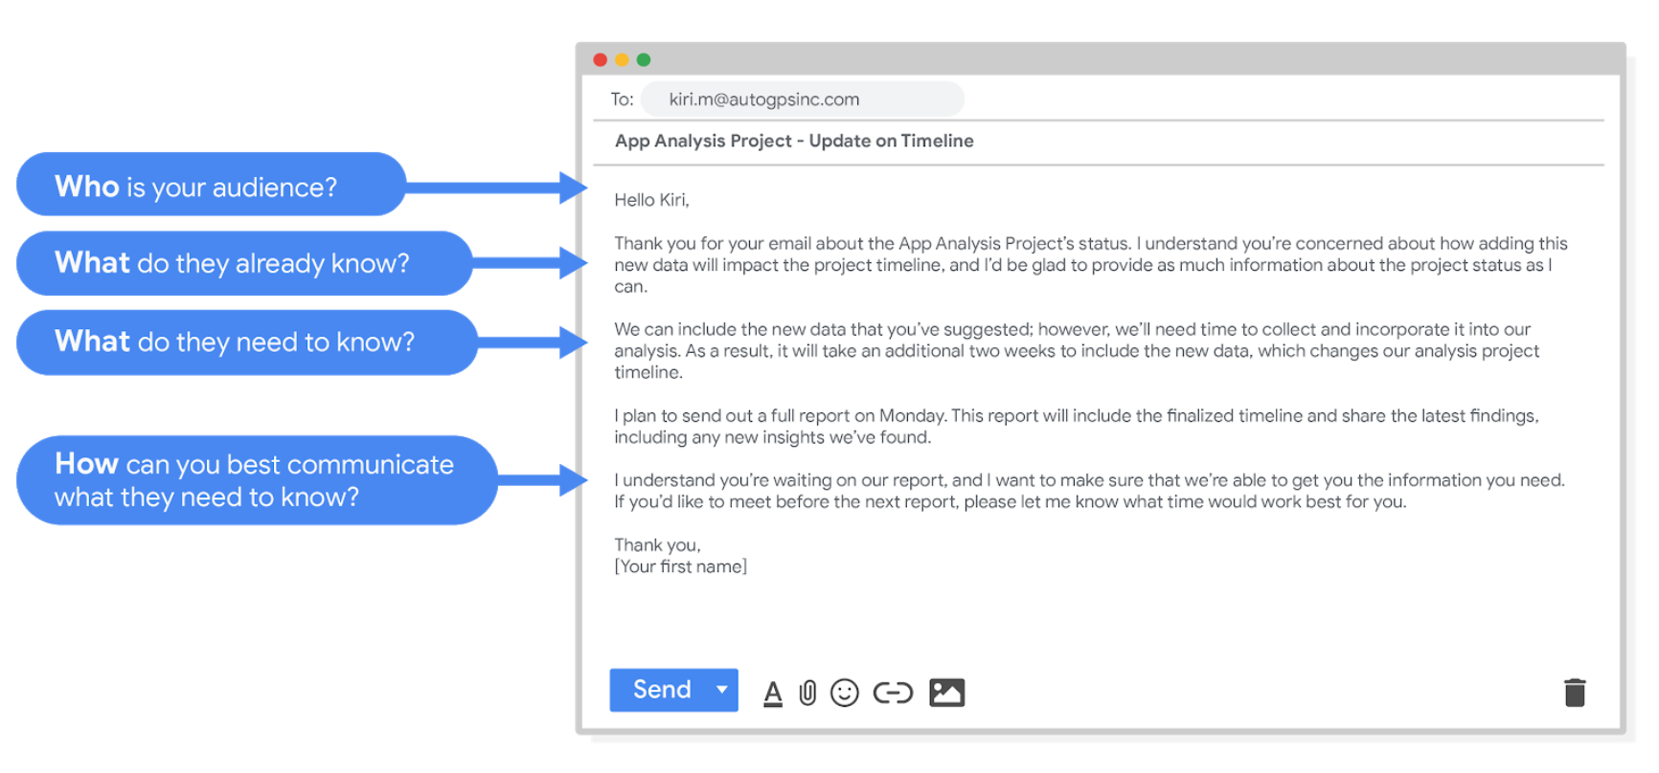

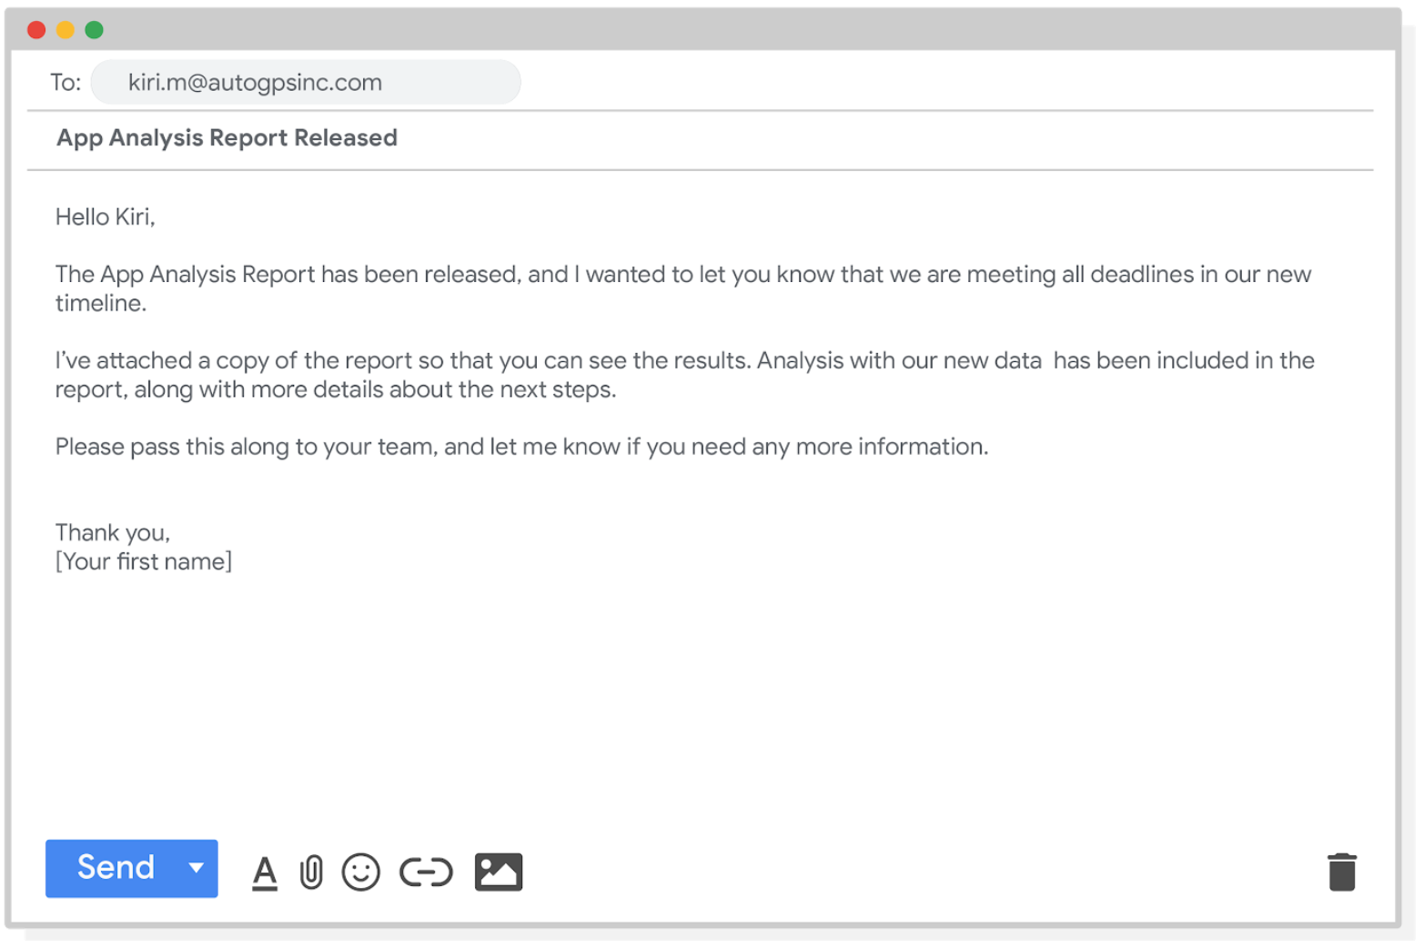

Good communication keeps stakeholders updated on progress and ultimately helps prevent problems. Carefully worded responses are key. Whether you gather and address feedback using email, meetings, or reports, everyone you work with will know what to expect. As a result, they will be able to better manage their own schedules, resources, and teams.